**PROJECT DEVELOPMENT PHASE**

**MODEL PERFORMANCE TEST**

|  |  |
| --- | --- |
| Date | 17 November 2022 |
| Team ID | PNT2022TMID52729 |
| Project Name | Project – Web phishing detection |
| Maximum Marks | 10 Marks |

**MODEL PERFORMANCE TESTING:**

Project team shall fill the following information in model performance testing template.

|  |  |  |  |
| --- | --- | --- | --- |
| **S.No.** | **Parameter** | **Values** | **Screenshot** |
|  | Dataset summary | data**.**describe()**.**T |  |
|  | Pairplot for particular features | df **=** data[['PrefixSuffix-', 'SubDomains', 'HTTPS','AnchorURL','WebsiteTraffic','class']]  sns**.**pairplot(data **=** df,hue**=**"class",corner**=True**); |  |

**ACCURACY, F1 SCORE, PRECISION AND RECALL SCORES:**

**1)LOGISTIC REGRESSION:**

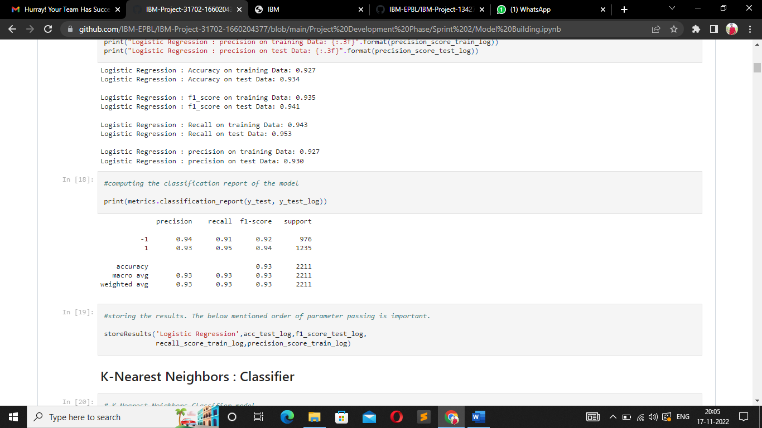

**2)K-NEAREST NEIGHBORS CLASSIFIER:**

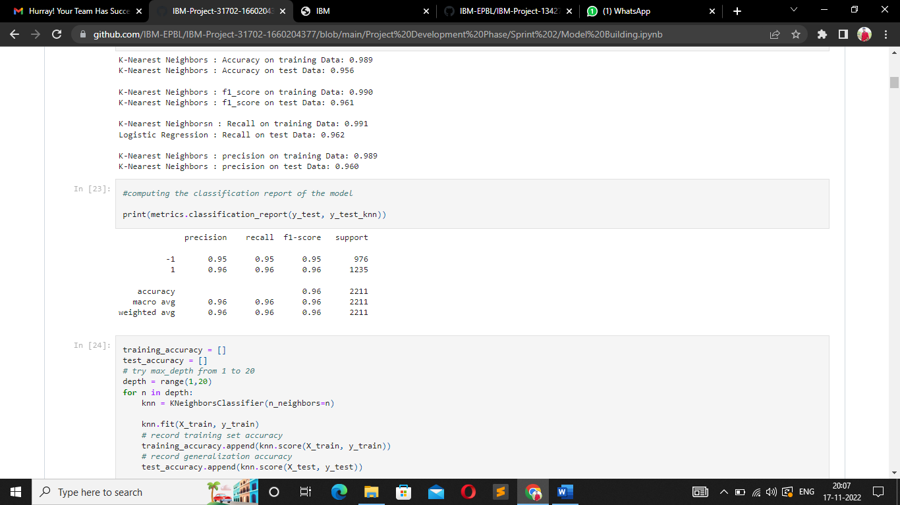

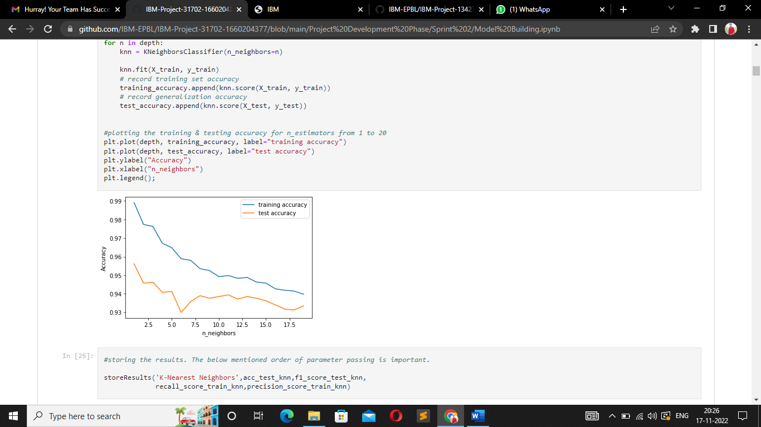

**3)SUPPORT VECTOR MACHINE:**

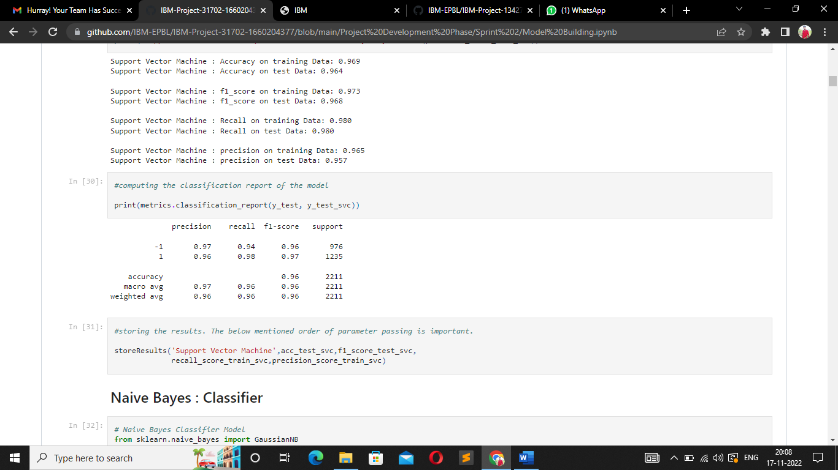

**4)NAIVE BAYES CLASSIFIER:**

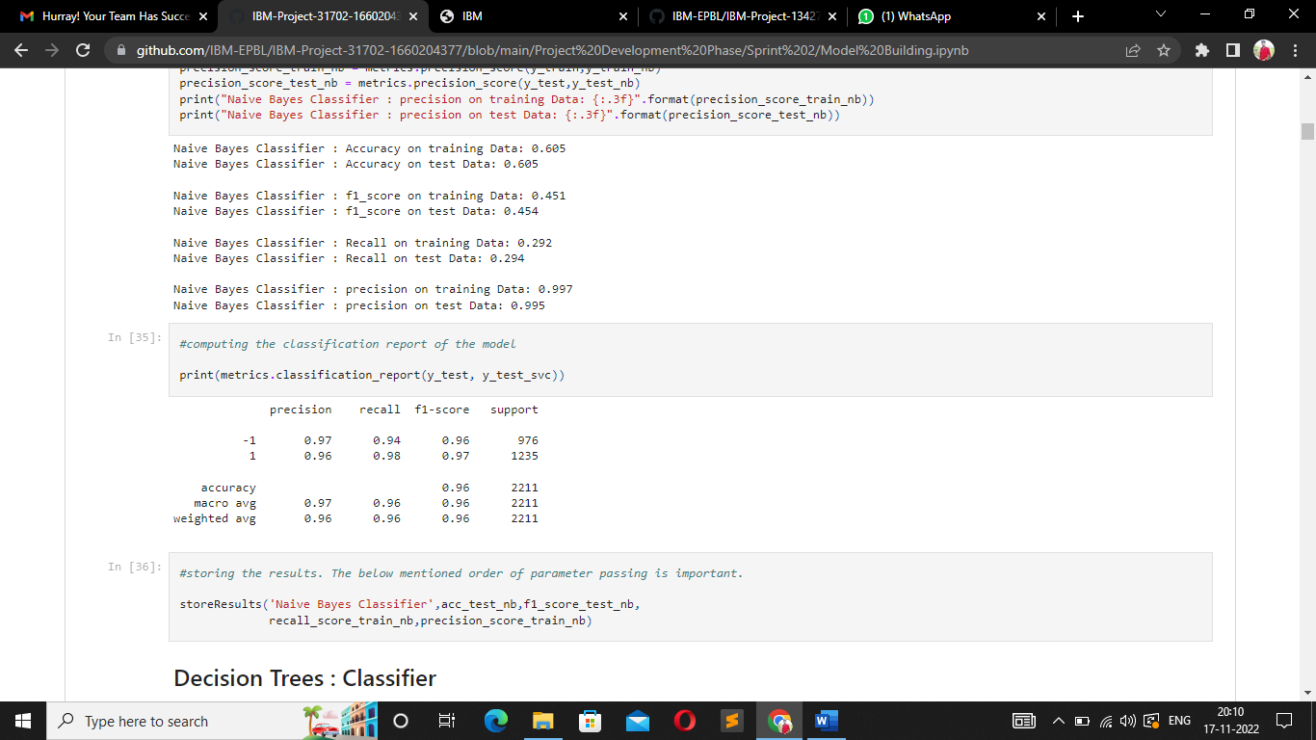

**5)DECISION TREE CLASSIFIER:**

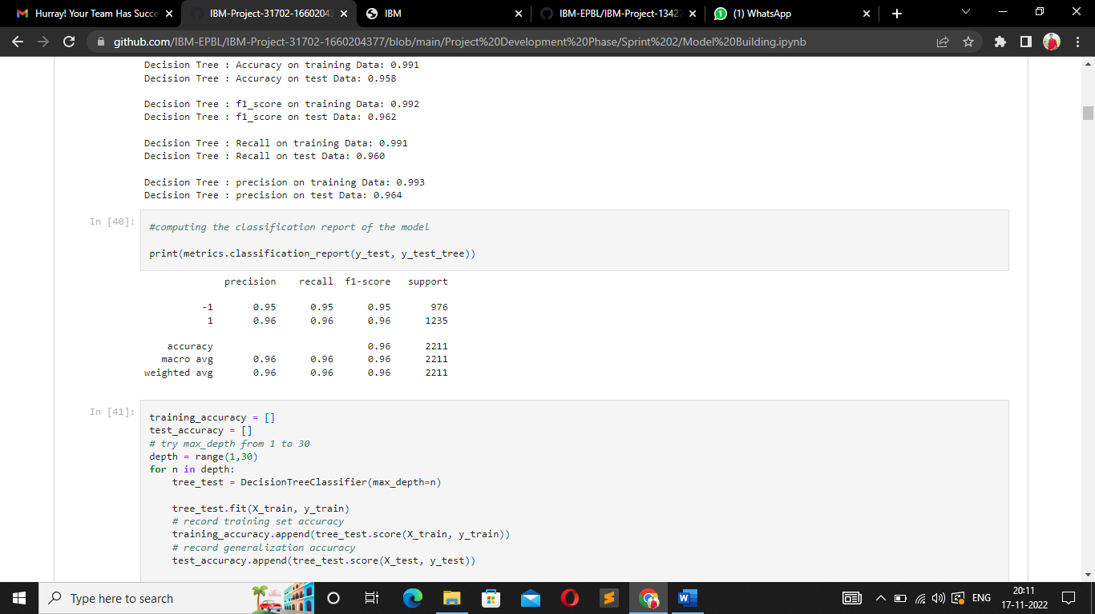

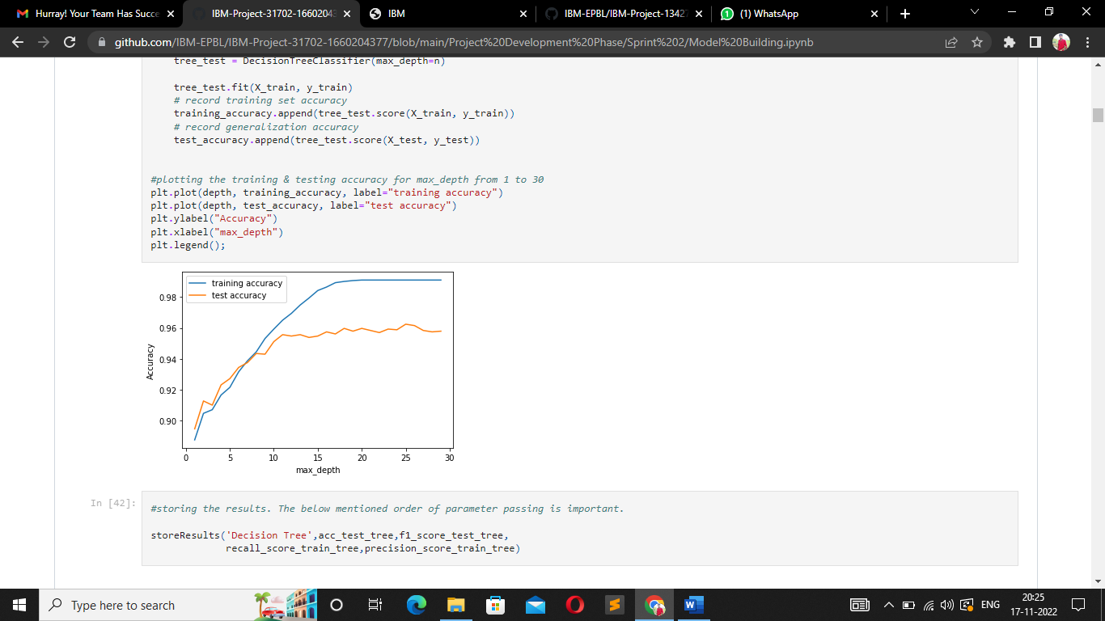

**6)RANDOM FOREST CLASSIFIER:**

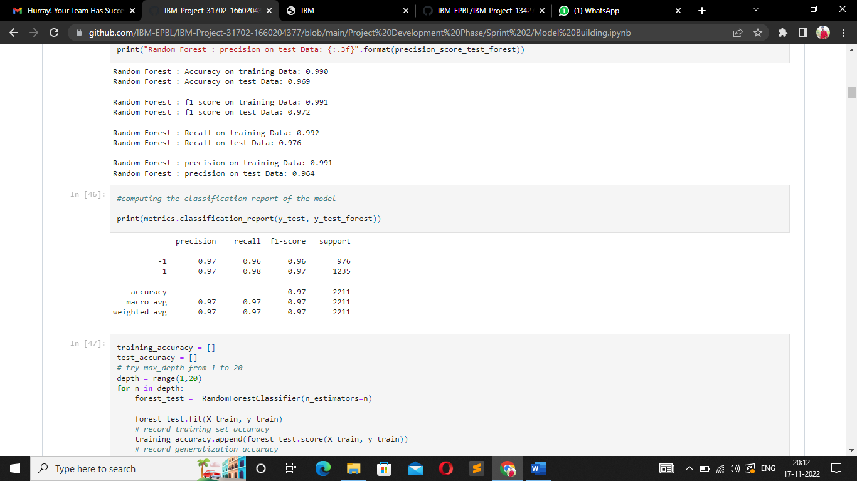

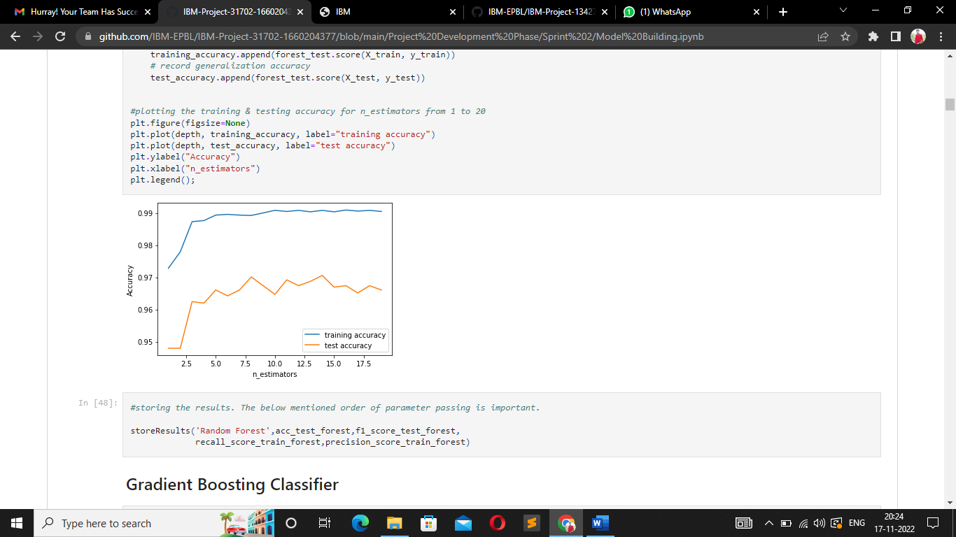

**7)GRADIENT BOOSTING CLASSIFIER:**

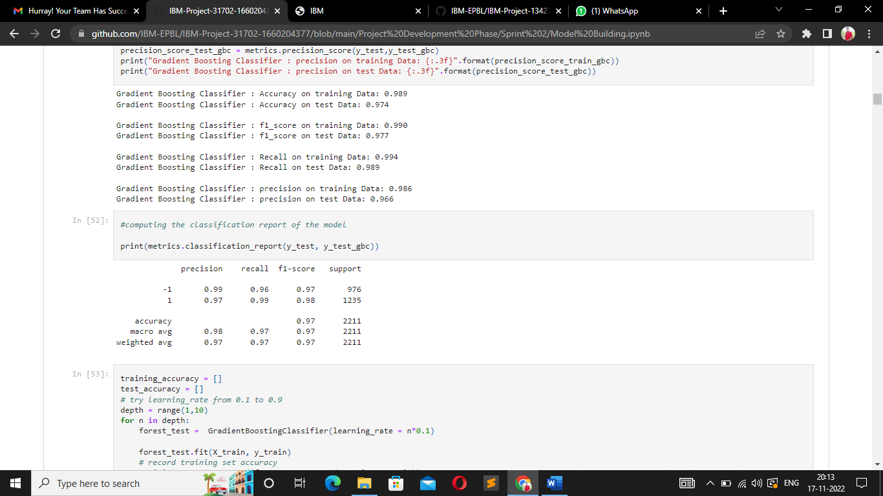

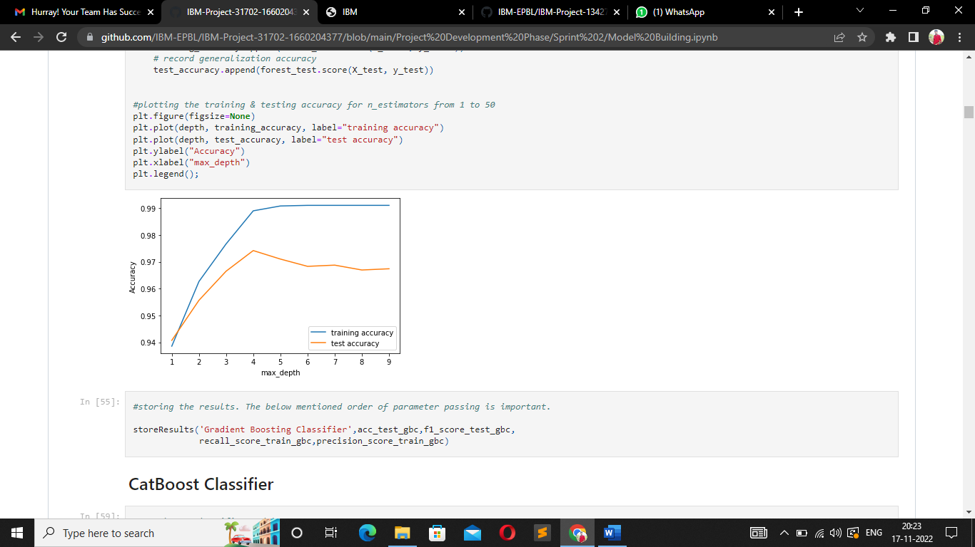

**8)XGBOOST CLASSIFIER:**

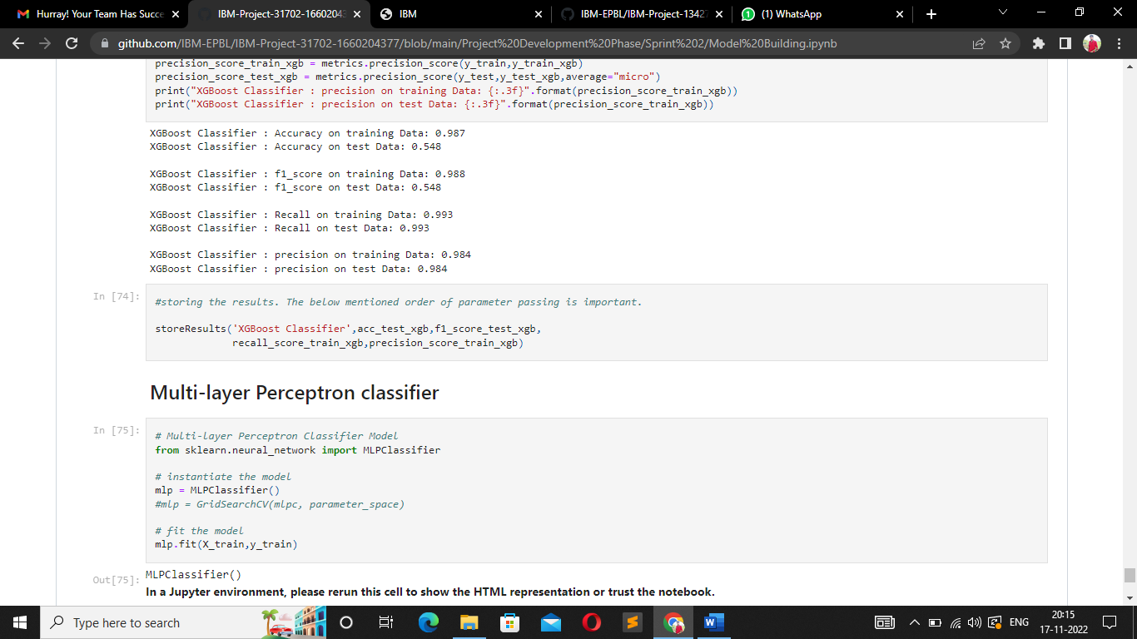

**9)MULTI LAYER PERCEPTRON CLASSIFIER:**

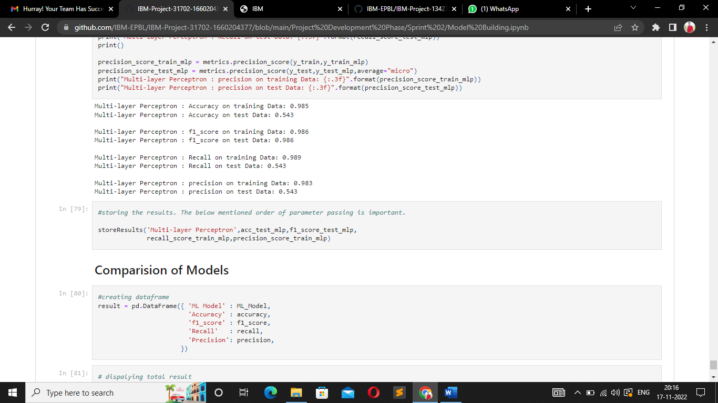

**COMPARISON OF MODELS:**

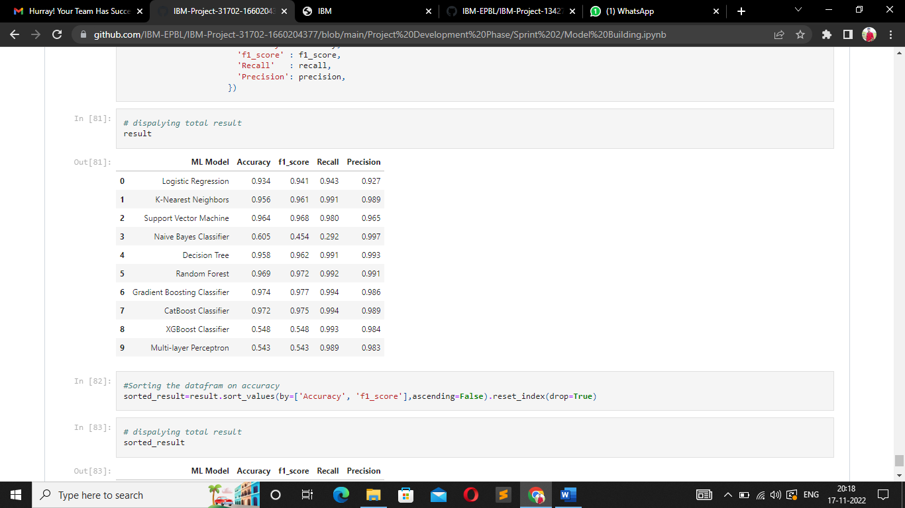

**SORTING OF MODELS BASED ON ACCURACY, F1 SCORE, RECALL AND PRECISON VALUES:**

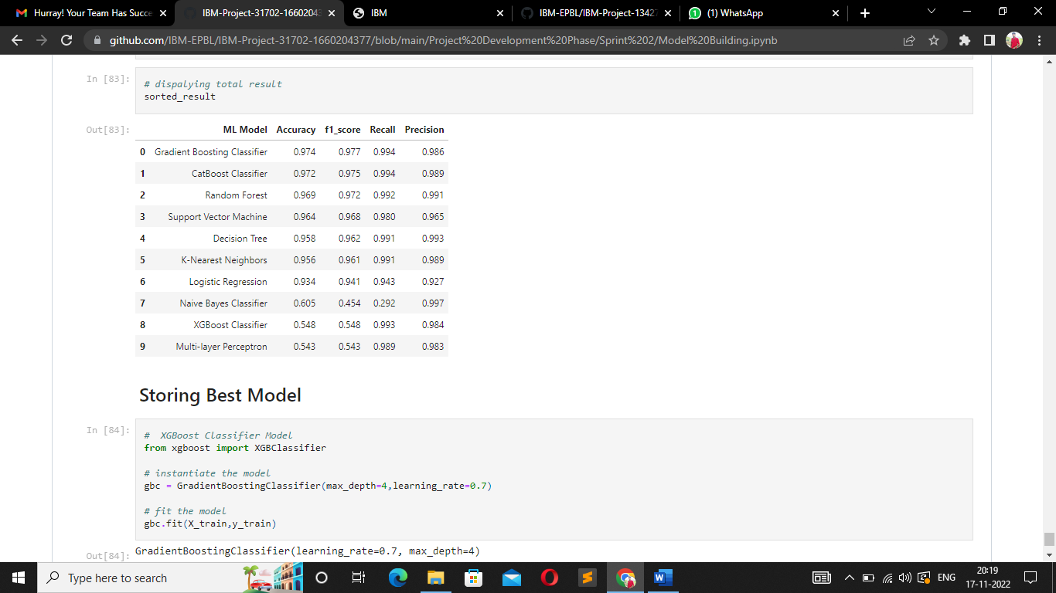

**IMPORTANCE OF FEATURES:**

